STUDENT ANALYSIS REPORT

**PROBLEM STATEMENT**

In the realm of education, there exists a multifaceted landscape of factors that may influence students' academic performance, often measured by their examination marks. Understanding and quantifying the impact of these factors is crucial for educators, policymakers, and educational institutions to enhance the learning experience and outcomes of students. This research aims to investigate the complex interplay between various factors and their influence on students' marks.

**OBJECTIVES**

The primary objectives of this study are as follows:

1. **Identify Key Factors:** Identify and categorize the diverse range of factors that may influence students' academic performance. These factors can encompass both internal and external aspects, including but not limited to socio-economic background, study habits, teacher quality, extracurricular activities, and health-related variables.

**The factors that are included in the analysis are as follows:**

Gender, Ethnic Group, Parents Education, Lunch Type, Test preparation, Parent marital status, Sports practice, Number of siblings, Transportation means and weekly studying hours,

**METHODS**

To accomplish these objectives, a comprehensive research study will be conducted. This study will involve data collection, statistical analysis, Surveys, interviews. Historical academic records may be used to gather data.

**SIGNIFICANCE**

Understanding the nuanced relationships between student performance and the multitude of influencing factors has the potential to revolutionize the field of education. By pinpointing the factors that matter most and tailoring educational interventions accordingly, we can work toward narrowing achievement gaps and fostering a more equitable and effective learning environment for all students.

**EXPECTED OUTCOME**

The research is expected to shed light on the significance of different factors in determining students' academic success. It will provide valuable insights that can guide educational policies, teaching practices, and support systems, ultimately leading to improved educational outcomes for students.

**FINDINGS:**

1. Gender difference between the students was not significant.

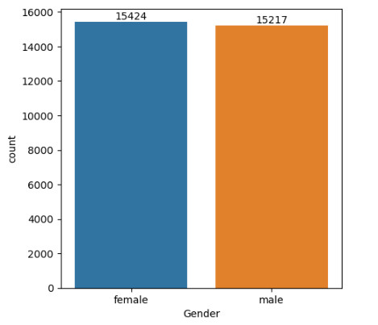

1. The education level of the students had a significant effect on the marks of the students. Students whose parent had the highest education level viz. master’s degree, scored the highest marks in all the test, while students whose parents have lower level of education have scored less marks in tests.

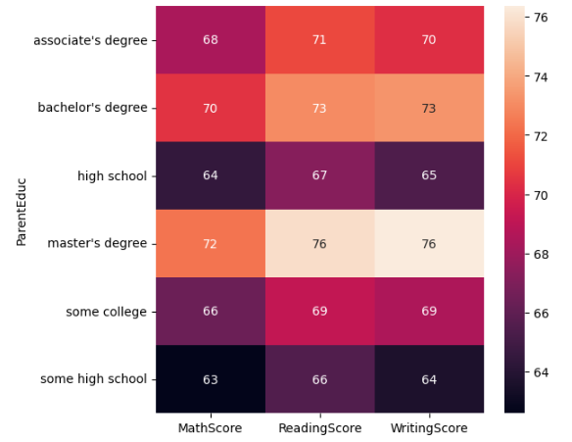

1. Significant relationship between the academic result and the marital status of the parent was not found. The difference across the different marital status is negligible.

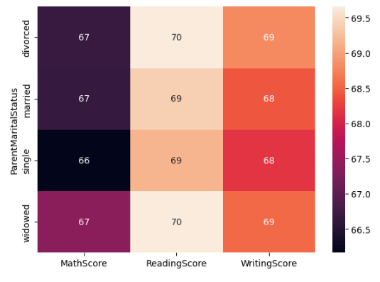

1. Weekly studying hours also didn’t have a significant impact on the student marks but it was found that the student studying more than 10 hours have maximum scores in all three tests. Hence it can be concluded that there is a proportional relationship between the studying hours and the test marks.

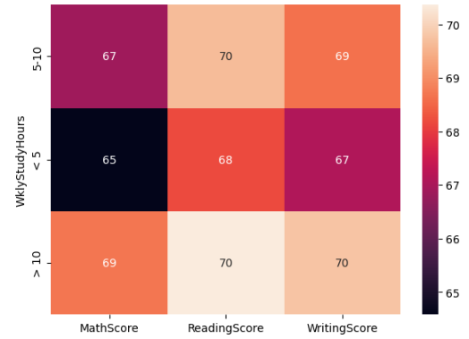

1. Boxplot for the student marks for each subject was developed to see the outliers. It will be helpful to understand that which subject is hardest for the student.

Boxplot for maths test:

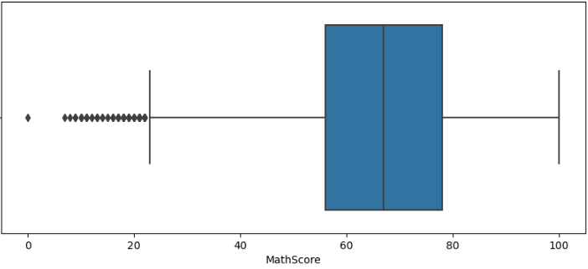

Boxplot for reading test:

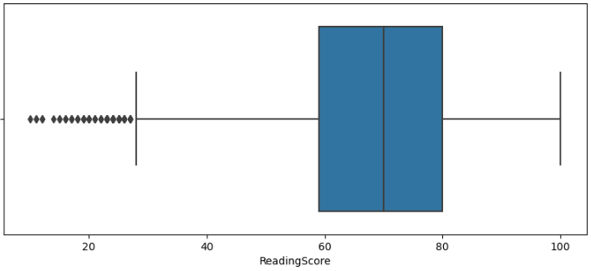

Boxplot for writing test:

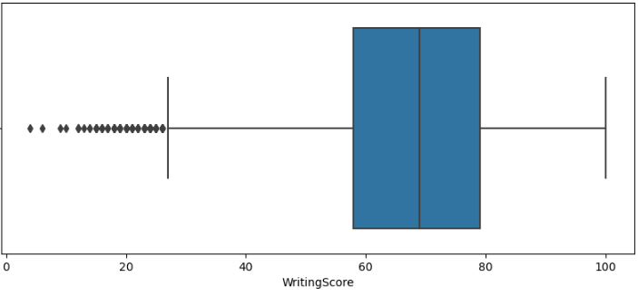

1. On studying the relationship between the sports engagement of the student and the academic results, it was found that:
2. Students who play sports on the regular basis has scored the maximum marks.
3. Student who play sports often, scored better marks than the student who don’t play sports.
4. Student who don’t engage themselves in sports activities scored the least marks in all three categories.

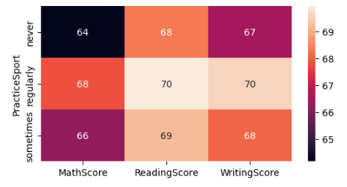

1. On further studies it was found that student who has prepared for the tests has scored significantly from those student who didn’t prepared for the tests. There was a significance difference between the two categories.

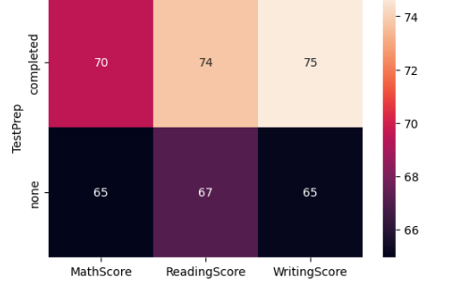

1. It was found that there was no significant difference between the number of siblings a student have and the test marks. The marks of the student that have the most siblings is almost similar to the marks of the student who have no siblings. Hence the difference between them is negligible.

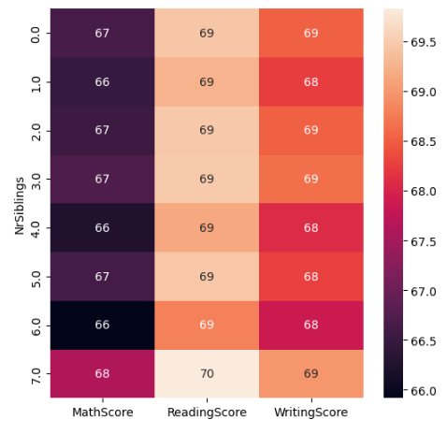

1. Rest of the columns like the student being the first child and the transport opted by the student to travel to the school are not mentioned in the findings as they do not have a significant impact on the student marks.